## Problem Statement:

### Problem

There are $N$ numbers $A_{1}$, $A_{2}$, …, $A_{n}$, and you are given $Q$ queries. In each query, you are given two integers $l$ and $r$. You are required to print the sum of all the numbers whose frequency of occurrence is between $l$ and $r$ (including $l$ and $r$). Print a single integer for each query in a new line.

### 

### Input format

The first line contains $N$ denoting the size of the array.

The second line contains $N$ integers denoting the elements of the array.

The third line contains $Q$ denoting the number of queries.

Next $Q$ lines contain $l$ and $r$.

### Output format

For each query, print the sum of all elements of the array whose frequency of occurrence is between $l$ and $r$ (inclusive) in a new line.

### 

### Constraints

$1≤N≤1000000$

$1≤A_{i}≤1000000$

$1≤Q≤1000000$

$1≤l≤r≤N$

| Sample Input | Sample Output |
| --- | --- |
| 8  4 4 6 5 3 3 3 9  4  1 4  2 7  3 7  5 6 | 37  17  9  0 |

Time Limit: 1

Memory Limit: 256

### 

### Explanation

In the first query we need to output the sum of all the numbers whose frequency of occurrence is between 1 and 4 (inclusive). Here all the given numbers have their frequecny between 1 and 4. 3 occurs 3 times, 4 occurs 2 times, 5, 6, 9 occurs 1 time. So the total sum would be 3+3+3+4+4+5+6+9 = 37.

## Working:

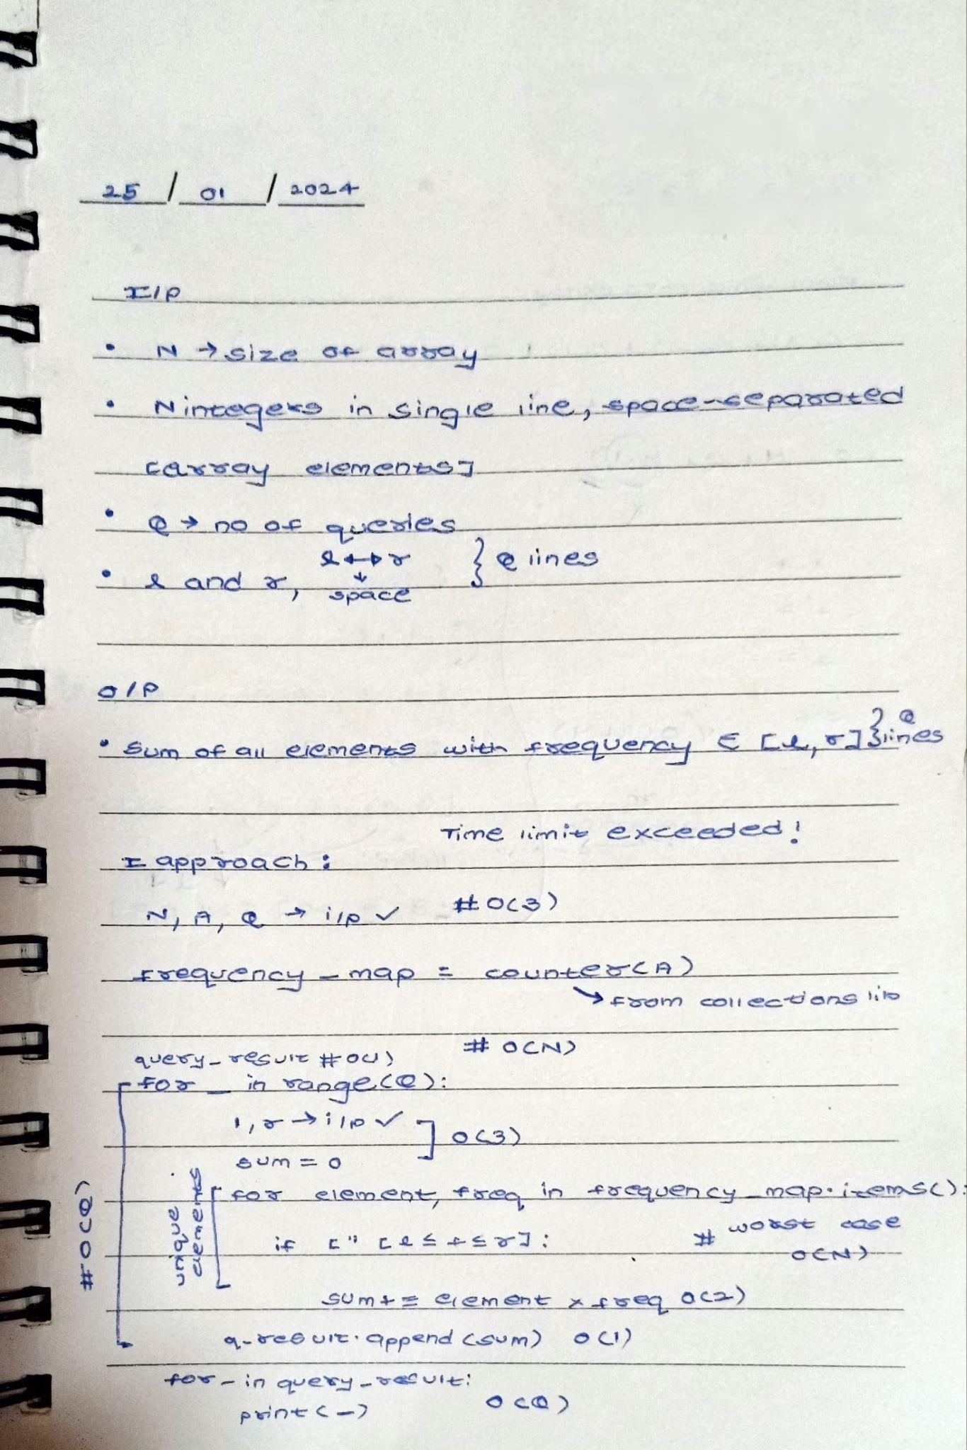

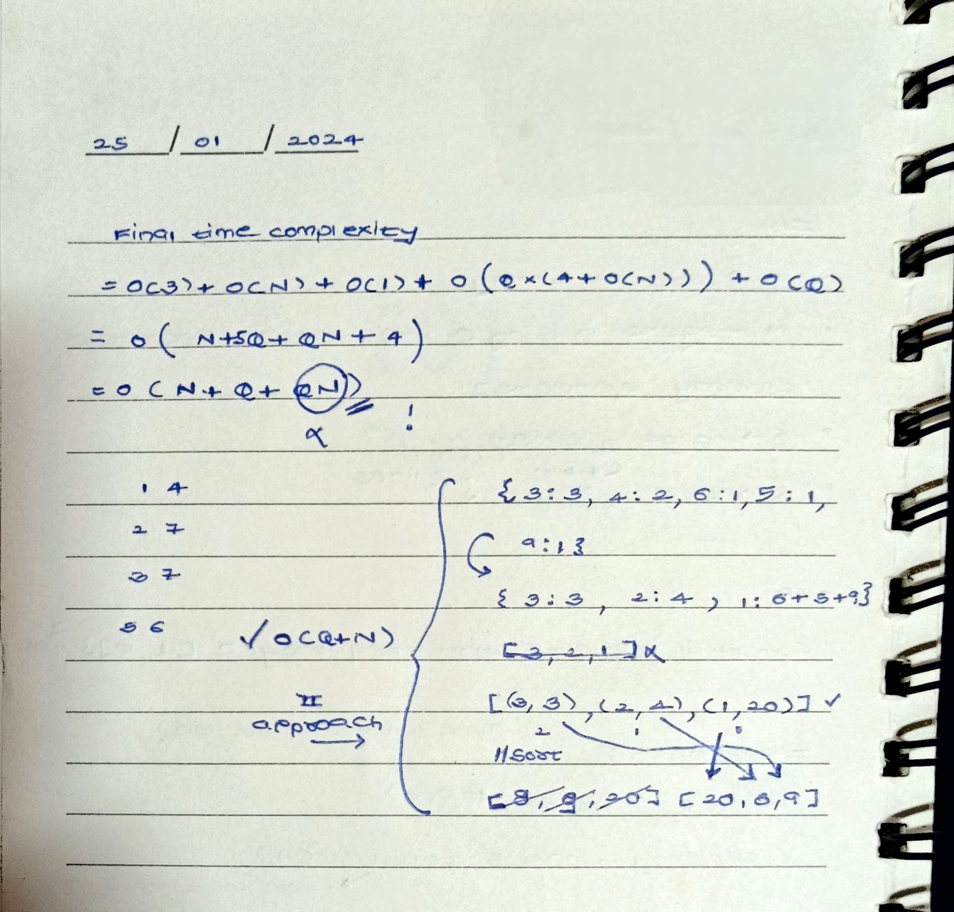

## Code:

from collections import Counter

from math import prod

N = int(input())

A = list(map(int, input().split()))

Q = int(input())

frequency_map = Counter(A)

k = {}

result = []

for element, frequency in frequency_map.items():

if frequency in k:

k[frequency] += element

else:

k[frequency] = element

freq_sorted = sorted(list(k.items()))

element_sum = list(map(prod, freq_sorted))

for i in range(Q):

l, r = list(map(int, input().split()))

result.append(sum(element_sum[l-1 : r]))

for i in result:

print(i)

## 

## 

## 

## 

## 

## Result: